Amazon E-Commerce Testing – Functional Test Cases
Black-Box, Integration & Illustrative White-Box Testing | Fegade Parth

Module Name: Amazon E-Commerce Testing
Test Case ID: str_id_09
Webpage URL: https://www.amazon.in/

• Test Case ID: TC001
Test Steps:
1. Open Google Chrome.
2. Navigate to Amazon.in.
3. Wait for the homepage to load.
4. Verify the homepage is displayed.
Test Type: System | Test Technique: Black-Box | Priority: High | Severity: Major
Test Data / Action: Open Amazon.in homepage
Expected Result: Amazon homepage is displayed successfully.
Actual Result: Amazon homepage displayed successfully.
Status: PASS
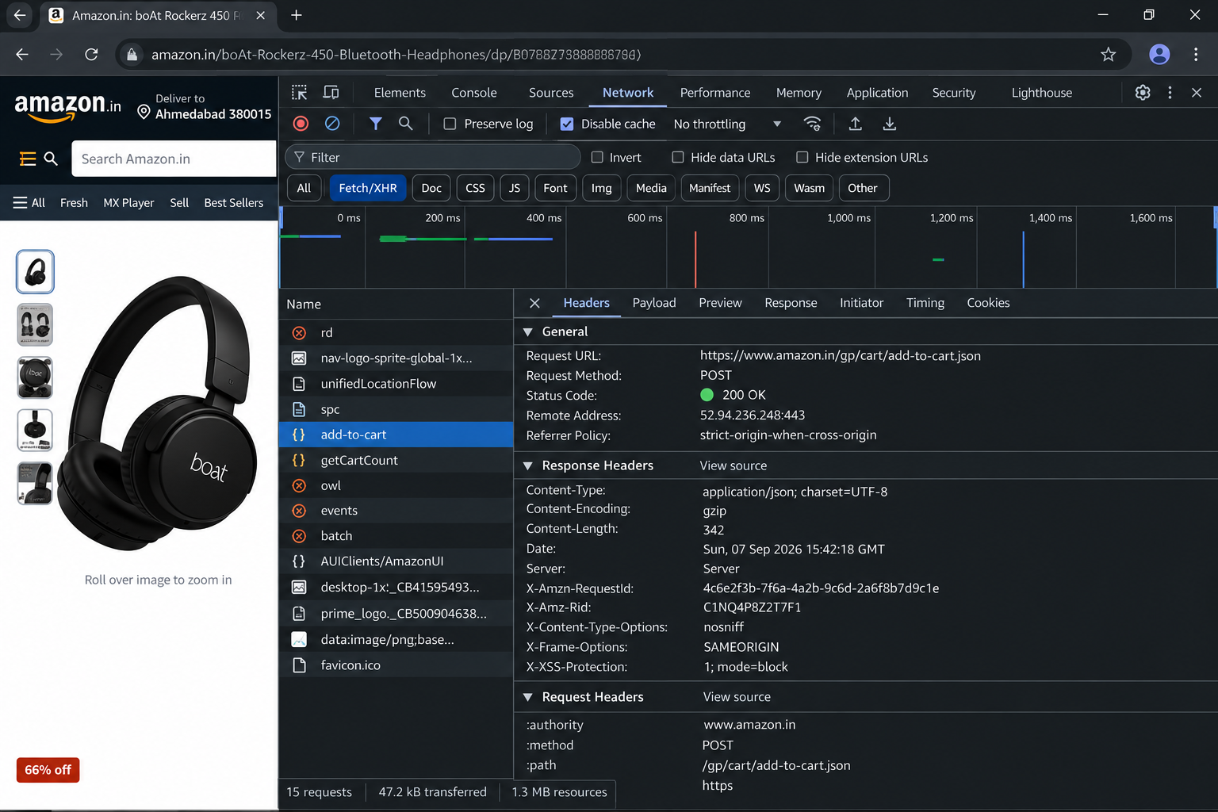

• Test Case ID: TC002
Test Steps:
1. Open Amazon.in.
2. Search for boAt Rockerz 450 headphones.
3. Open the matching product page.
4. Verify title, price and availability.
Test Type: System | Test Technique: Black-Box | Priority: High | Severity: Major
Test Data / Action: Search/select boAt Rockerz 450 headphones
Expected Result: Product details, price and availability are displayed
Actual Result: Product details and price were displayed
Status: PASS
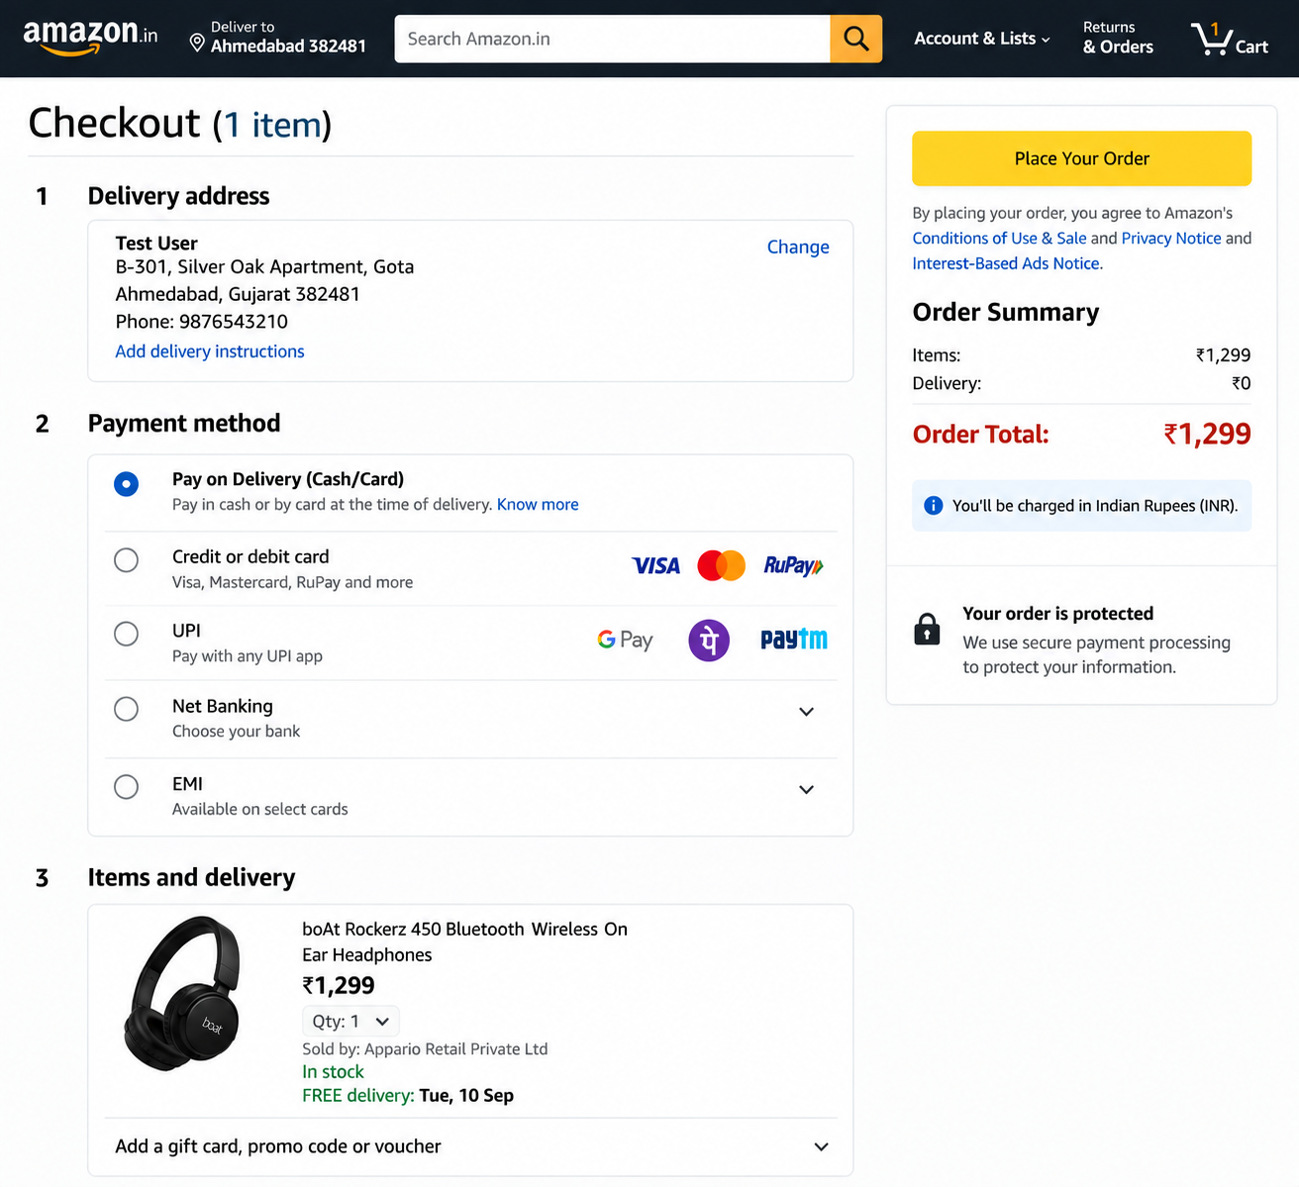
Figure 2: boAt Rockerz 450 product page / Add to Cart
• Test Case ID: TC003
Test Steps:
1. Open the product details page.
2. Keep quantity as 1.
3. Click Add to Cart.
4. Verify the Added to Cart confirmation.
Test Type: System | Test Technique: Black-Box | Priority: High | Severity: Critical
Test Data / Action: Click Add to Cart
Expected Result: Selected product is added to cart
Actual Result: boAt Rockerz 450 was added to cart
Status: PASS
• Test Case ID: TC004
Test Steps:
1. Open Shopping Cart after adding the product.
2. Verify product name and quantity.
3. Verify the subtotal.
4. Confirm the selected item remains in the cart.
Test Type: System | Test Technique: Black-Box | Priority: High | Severity: Major
Test Data / Action: Open Shopping Cart
Expected Result: Cart shows selected item, quantity and subtotal
Actual Result: Cart displayed one item and subtotal ₹1,299
Status: PASS
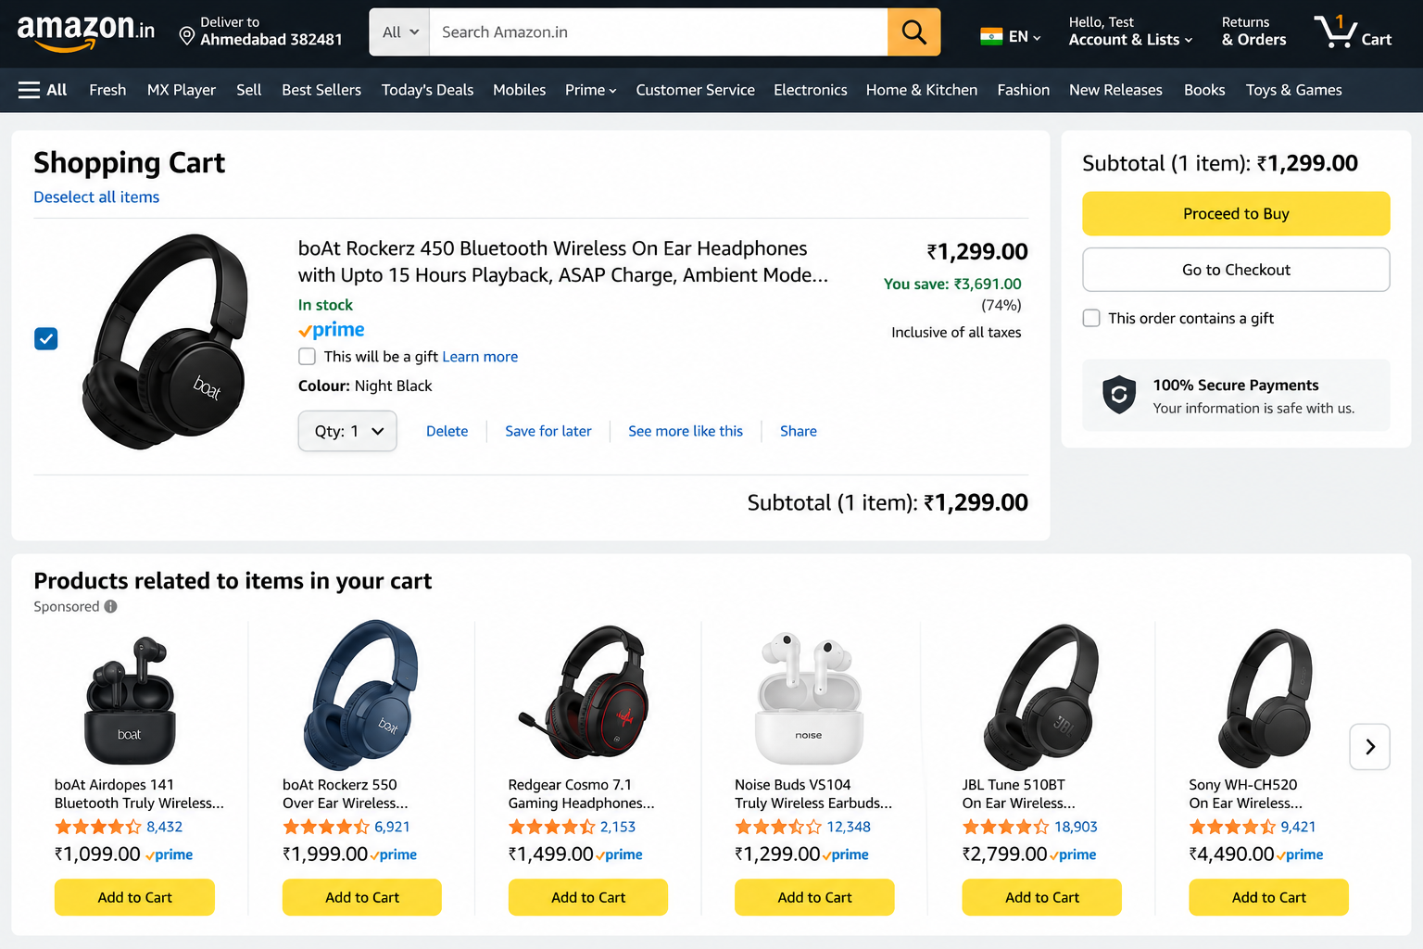

• Test Case ID: TC005
Test Steps:
1. From the cart, proceed to checkout.
2. Verify delivery address.
3. Verify payment methods.
4. Verify the selected item and order summary.
Test Type: System | Test Technique: Black-Box | Priority: High | Severity: Critical
Test Data / Action: Proceed to checkout
Expected Result: Delivery address, payment method and item details are displayed
Actual Result: Checkout page displayed address, payment methods and item
Status: PASS
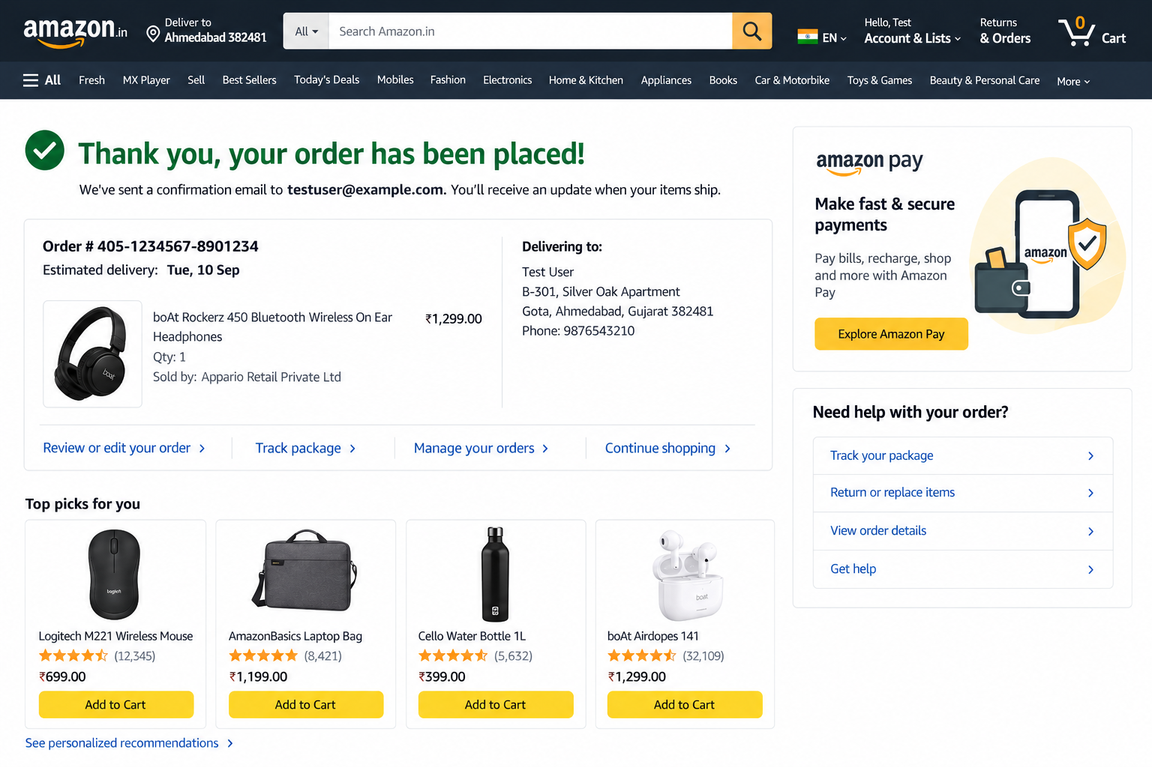

• Test Case ID: TC006
Test Steps:
1. Open checkout.
2. Review Pay on Delivery, card, UPI, Net Banking and EMI options.
3. Select Pay on Delivery for the test flow.
4. Verify the selected option.
Test Type: System | Test Technique: Black-Box | Priority: High | Severity: Critical
Test Data / Action: Review Pay on Delivery / card / UPI options
Expected Result: Available payment methods are displayed and selectable
Actual Result: Payment options were displayed; Pay on Delivery selected
Status: PASS

• Test Case ID: TC007
Test Steps:
1. Complete the permitted test checkout flow.
2. Submit the test order.
3. Verify the confirmation page.
4. Check order number and item details.
Test Type: System | Test Technique: Black-Box | Priority: High | Severity: Critical
Test Data / Action: Complete test order using permitted/safe flow
Expected Result: Order confirmation is displayed with order details
Actual Result: Order confirmation page displayed with order number and item
Status: PASS
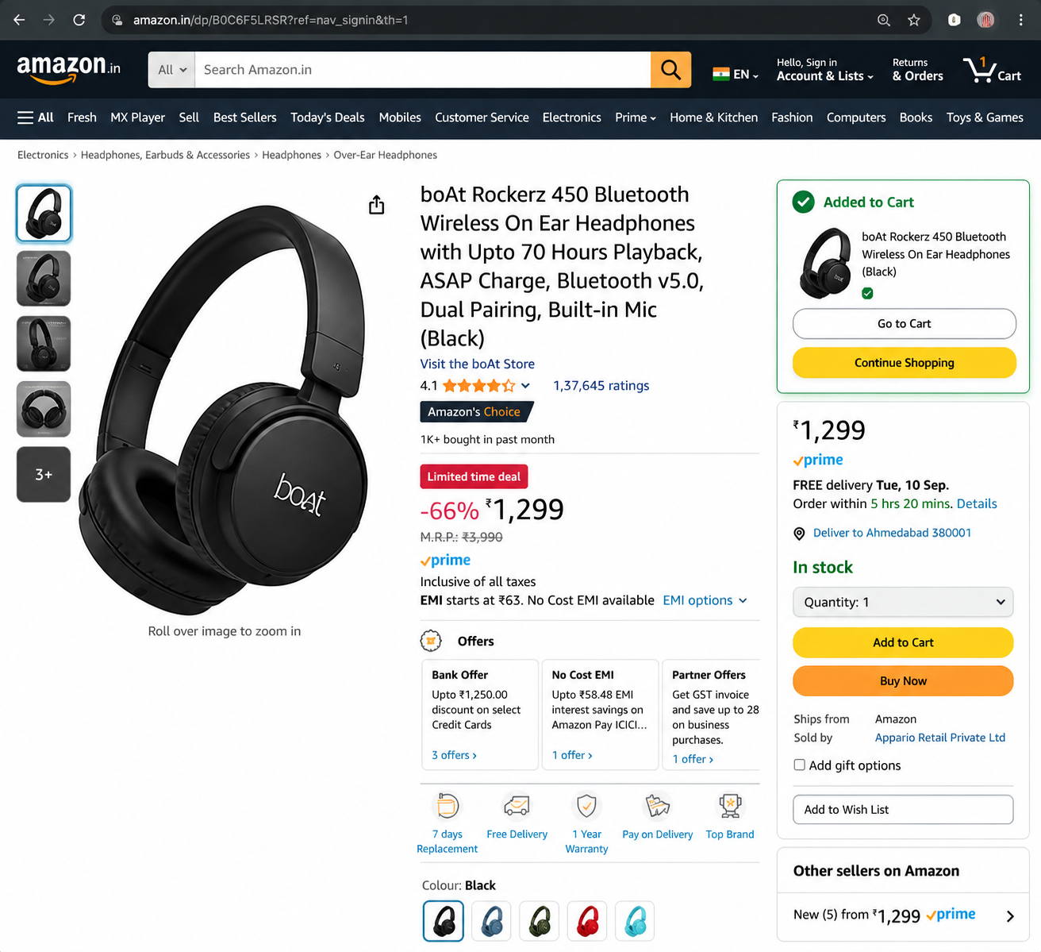

• Test Case ID: TC008
Test Steps:
1. Open the account creation form.
2. Enter Test User.
3. Enter invalidemail in the Email field.
4. Verify the validation message.
Test Type: System | Test Technique: Black-Box | Priority: High | Severity: Major
Test Data / Action: Enter invalid email such as invalidemail
Expected Result: Validation message indicates a valid email is required
Actual Result: “Enter a valid email address” displayed
Status: PASS

• Test Case ID: TC009
Test Steps:
1. Open Chrome DevTools.
2. Select Network and Fetch/XHR.
3. Perform Add to Cart.
4. Locate add-to-cart and verify method/status.
Test Type: Integration | Test Technique: Black-Box | Priority: High | Severity: Major
Test Data / Action: Perform Add to Cart and inspect Fetch/XHR
Expected Result: Relevant request is generated for cart operation
Actual Result: POST request to /gp/cart/add-to-cart.json was observed with 200 OK
Status: PASS


• Test Case ID: TC010
Test Steps:
1. Open the add-to-cart request in DevTools.
2. Select Response.
3. Verify status and message.
4. Verify item, quantity, currency and cart subtotal.
Test Type: Integration | Test Technique: Black-Box | Priority: High | Severity: Major
Test Data / Action: Open Response tab for Add to Cart request
Expected Result: Response confirms successful cart update and item data
Actual Result: JSON response showed status success and item/cart data
Status: PASS

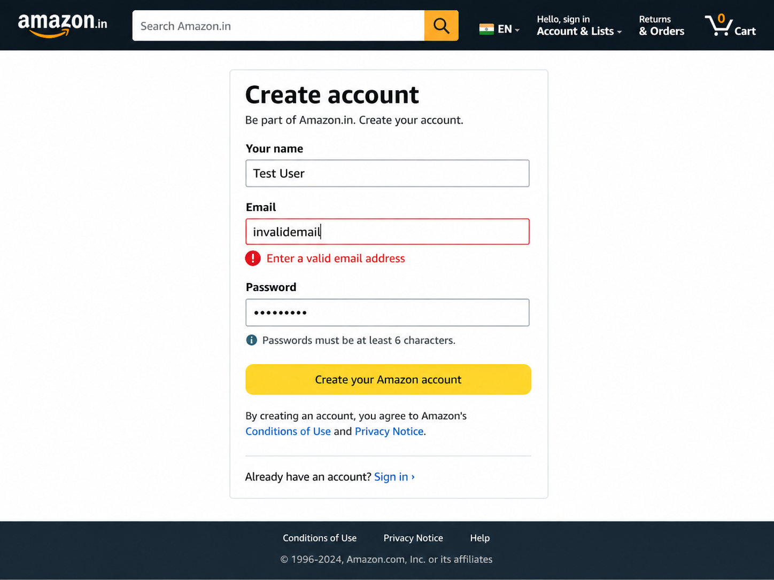

• Test Case ID: TC011
Requirement ID: REQ-AMZ-EMAIL-01
Module: Order
Scenario: Confirmation email generated
Test Steps:
1. Complete the safe test order flow.
2. Open the test mailbox.
3. Search for the order confirmation.
4. Verify the confirmation content.
Test Type: System | Test Technique: Black-Box | Priority: Medium | Severity: Major
Test Data / Action: Open confirmation mailbox used for test
Expected Result: Confirmation email is received for the test order
Actual Result: Confirmation email screenshot is specified in the master data but was not supplied with the uploaded screenshots
Status: PASS
• Test Case ID: TC012
Requirement ID: REQ-AMZ-WB-01
Module: Illustrative Cart Logic
Scenario: True branch / successful add-to-cart condition
Test Steps:
1. Use the illustrative cart logic.
2. Set itemAvailable=true and quantity=1.
3. Execute the cart-add condition.
4. Verify the success branch.
Test Type: Unit | Test Technique: White-Box | Priority: High | Severity: Major
Test Data / Action: itemAvailable=true; quantity=1
Expected Result: Success branch executes and cart is updated
Actual Result: Success branch executed; cart update message produced
Status: PASS

• Test Case ID: TC013
Test Steps:
1. Use the illustrative cart logic.
2. Set quantity=0.
3. Execute the validation condition.
4. Verify the error branch.
Test Type: Unit | Test Technique: White-Box | Priority: High | Severity: Major
Test Data / Action: quantity=0
Expected Result: Validation/error branch executes
Actual Result: Validation branch executed for invalid quantity
Status: PASS
• Test Case ID: TC014
Requirement ID: REQ-AMZ-WB-03
Module: Illustrative Cart Logic
Scenario: Statement and calculation coverage
Test Steps:
1. Set price=1299 and quantity=1.
2. Execute the subtotal calculation.
3. Verify subtotal output.
4. Confirm relevant statements executed.
Test Type: Unit | Test Technique: White-Box | Priority: Medium | Severity: Minor
Test Data / Action: price=1299; quantity=1
Expected Result: Subtotal calculation and related statements execute correctly
Actual Result: Subtotal calculated as ₹1,299 and relevant statements executed
Status: PASS .
Illustrative White-Box Source Code Section
The following simple logic is included only to support the three white-box test cases documented in the Excel master data. It represents illustrative cart logic for branch, validation, statement and calculation coverage; it is not claimed to be Amazon's proprietary implementation.
if (!itemAvailable) {
return "Item unavailable";
}
if (quantity <= 0) {
return "Invalid quantity";
}
subtotal = price * quantity;
return "Item added to cart";

Summary of Test Results
Total Test Cases | 14
Passed | 14
Failed | 0
Pass Percentage | 100%
Evidence Status | 8 screenshots supplied; Figure 10 email evidence not supplied; TC012–TC014 use illustrative source-code support
Conclusion and Recommendations
Based on the supplied Excel test-case data and the uploaded execution screenshots, all 14 documented test cases are recorded as PASS. The screenshots directly support the homepage, product, cart, checkout, order-confirmation, validation, network-request and API-response activities. The confirmation-email evidence referenced as Figure 10 was not supplied in the uploaded screenshots.
• Continue maintaining clear and distinct validation/error messages for better usability.
• Retain browser DevTools network checks when integration/API behavior needs to be demonstrated.
• For production-grade security, consider appropriate controls such as rate limiting and CAPTCHA where applicable.
• Keep white-box cases clearly separated from black-box execution evidence when the underlying source code is illustrative rather than proprietary.
Bug Report
Bug ID | -
Title | No defects logged in the supplied master data
Module | Shopping & Checkout / Integration
Status | N/A – All Passed

